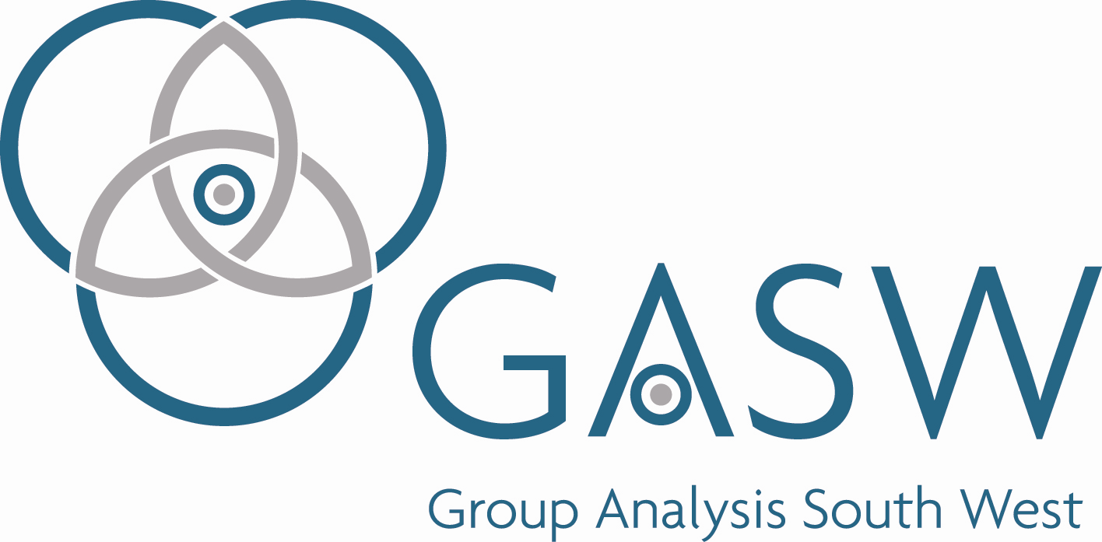

FULL MEMBERSHIP
APPLICATION/ RENEWAL FORM

GASW is a Membership Organisation.

As full members you are eligible for participation in a monthly Median Group and regular Business meetings. You are also eligible for registration with UKCP. In order to maintain this registration and remain a member of GASW you are required to complete this form annually and pay your annual membership fee.

GASW membership runs from January to December each year. If you join part way through the year your membership fee will be adjusted accordingly.

Full membership fee 2025: £150

- Your Details

Please enter details below
Full Name
Address inc. postcode
Email
Mobile
Alternative Tel no

- Confirmation of Insurance

Insurance details
Name of Insurer
Expiry date of insurance
Please confirm you have attached a copy
of your insurance certificate

- Confirmation of Clinical Will (private practice only)

Clinical Will | Yes/No/NA
If you work in Private Practice, please confirm you have a
clinical will in place
Please confirm you have appointed a clinical executor

- Membership Directory consent

GASW produces an annual membership directory which is shared amongst members. It is also accessible in the members only area of the website to students studying on GASWs Foundation, Diploma and Qualifying courses.

We need your consent to share your information on the membership directory. Please indicate which information you want included in the Directory by deleting as appropriate. We will take this as evidence that you have consented to share this information.

Details | I consent to share this information –*delete as  appropriate
Name | I do/do not want this included in the members directory
Email | I do/do not want this included in the members directory
Mobile | I do/do not want this included in the members directory
Alternative Tel no | I do/do not want this included in the members directory

- GASW Code of Ethics and Professional Practice

The UKCP now require members to confirm they have read the GASW Code of Ethics and Professional Practice updated in March 2025. This document has been sent with the membership renewal email. Please confirm below that you have read the document.

GASW Code of Ethics and Professional Practice
I hereby confirm that I have read the GASW Code of Ethics and Professional Practice. Please indicate by circling the box that you have read it. | YES / NO

- Payment

Payment of membership fees are now required to be made in full by BACS payment. Please advise if you require an invoice.

Please use your initial and your surname as your reference when making your payment.

Account Name: Group Analysis South West No.2 A/C
Sort code: 08-92-99
Acct. No: 65220236

- Confirmation
I confirm these details are correct and I confirm the consents given to be included in the membership directory.
SIGNATURE*: DATE:
*GASW accepts a typed signature when returning the form electronically. Please return this form to info@gasw.org.uk

Updated December 2025

